|  |
| --- |
| 新东方在线英语学习 |
| 新概念 1 册 |
| Lesson103-104 |



扫一扫。更多有趣的英语资讯。

# Lesson 103 单词讲解

1.exam: n.考试examination

考场，examination room test, 水平测试

TOEFL: Test of English as a Foreign Language

IELTS: International English Language Testing System 2.pass: v.及格，通过

pass in + 具体科目

3.mathematics: n.数学math

maths 4.question: n.问题

题，做题，answer the question 5.easy: adj.容易的

1. enough: adv.足够地easy enough enough money

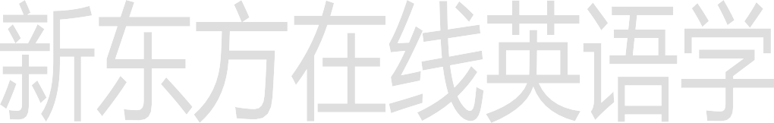adj.+ enough enough + n.

1. paper: n. 考 卷 8.fail: v.未及格，失败

I will fail math. Our plan will fail.

1. answer: v.回答answer the question 回答问题，做题answer the phone
2. mark: n.分数score

high score low score

取得高分，make a high score

Our class made a high score in the last test.

1. rest: n.其他的东西

We'll eat some of the bread and keep the rest for breakfast.

1. difficult: adj.困难的13.hate: v. 讨 厌 14.low: adj.低的

a low mark

1. cheer: v.振作，振奋Cheer up!
2. guy: n.家伙，人

gay

1. top: n.上方，顶部at the top of…

考卷的上方：

at the top of the paper

at the bottom of...bao dom

You can see a fish at the bottom of the lake.

# Lesson 103 课文讲解

1. Not too bad.

还好啦，凑合。

1. I passed in…
2. I …sixteen of the questions. can- could

16 个问题：sixteen questions

sixteen of the questions: 其中的 16 个问题两位老师：two teachers

其中的两位老师：two of the teachers

1. They were too … for me.



too difficult, 太难

（以至于不会，暗含否定）

for me, 对于我来说

5. French … are awful, aren’t they?

法语考试非常讨厌，不是吗？

1. Cheer up!
2. The guy [next to me]… 坐在我旁边那家伙the ones [on the shelf]

the beauty [behind me] 他一句话都没说。 He didn’t say a word.

他一分钱都没挣。

He didn’t make any money.

# Lesson 103 语法讲解

too**：太…（以至于不能，否定含义）**

very**：非常…** enough**：够…** too…

The apple is too sweet.

The boy is too handsome. 不能这么说 too含义否定

You are too late.

The baby is too young to eat by himself. too…to… 太…以至于不能…

今天太冷我没法出去。

It is too cold for me to go out.

他走得太慢，不能按时到达那儿。 He walks too slowly to get there on time. 他太忙根本没时间见我。

He is too busy to see me. 这帽子太大，没法戴。The hat is too large to wear. **too+ adj/adv.+ to…**

very…（程度副词 可以修饰形容词和副词）

very pretty very much enough… enough+ n.

adj.+ enough

天够冷的：It is cold enough.

我有足够的时间来读书：

I have enough time to read.

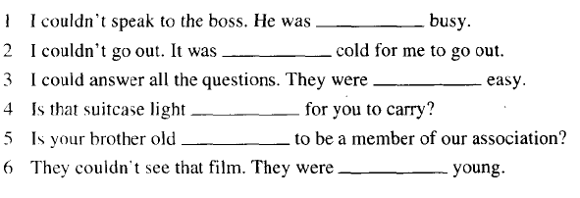

# Lesson 104 单词句型讲解

1. clever: adj.聪明的身体的灵巧

思维敏捷、足智多谋

较快地理解掌握所学知识/技能

smart:

思维能力强,办事巧妙,圆滑处理人际关系

1. stupid: adj.笨的

缺乏理智,先天迟钝、智力低下

silly:

缺乏常识、判断力,作出令人可笑的行为和举止

1. cheap: adj.便宜的
2. 4.expensive: adj.贵的ei ke si ben sei
3. 5.fresh: adj.新鲜的

6.stale: adj.变馊的7.low: adj.低的，矮的8.loud: adj.大声的9.high: adj.高的10.hard: adj.硬的11.soft: adj.软的12.sweet: adj.甜的13.sour: adj.酸的

bitter: adj.苦的

too

1. Never too old to learn.

活到老学到老。

1. Life is too short to waste.

# Lesson 103&104 知识拓展

生命短暂，经不起浪费。

